Social Media Resources for Launch Week (and after) for The Building
{For Kevin’s friends}

Suggested Text for Social Media Posts without word/character limits:
A terrific author I follow has a new novel out called The Building. It’s a gripping story that includes real characters, a unique setting, and a cautionary tale about the hidden dangers behind high-tech systems (including Artificial Intelligence) that can be manipulated. Get yours today and be one of the first people talking about this viral thriller.

“The tension builds with precision, with each revelation tightening the coil until one is holding their breath alongside the characters. . . . It delivers on all fronts including emotional investment, thematic depth, and pure suspense.” ~Feathered Quill Reviews

Get your Kindle or Audible edition from Amazon here: https://mybook.to/The_Building
Order Audiobooks and autographed paperbacks and Hardcovers directly from Kevin here: https://kevingchapman.com/direct-sales-best-value/

Suggested Text for Twitter/X, BlueSky, and other platforms with word limits:
A terrific author I follow has a new novel out called The Building. It’s a gripping story that includes real characters, a unique setting, and a cautionary tale about the hidden dangers behind high-tech systems (including Artificial Intelligence) that can be manipulated. Get yours today and be one of the first people talking about this viral thriller.

Get your Kindle or Audible edition from Amazon here: https://mybook.to/The_Building
Order Audiobooks and autographed paperbacks and hardcovers directly from Kevin here: https://kevingchapman.com/direct-sales-best-value/

Alternate Text for any social platform:

Anthropic techs warn that AI may start killing humans within a decade. This is how it begins. Get in on the conversation about this viral thriller!

“The tension builds with precision, with each revelation tightening the coil until one is holding their breath alongside the characters. . . . It delivers on all fronts including emotional investment, thematic depth and pure suspense.” ~Feathered Quill Reviews

Order now on Amazon for Kindle and Audible https://mybook.to/The_Building , or order audiobooks and autographed paperbacks and hardcovers directly from the author now: https://kevingchapman.com/direct-sales-best-value/

Images for your Post: (See below)
(Right-click on an image (whichever one you like best) and choose “save as” or “save as picture” to save to your phone or computer, then add to your Instagram post)

If you past in the text and links without a photo, the platform will use the image associated with the link.

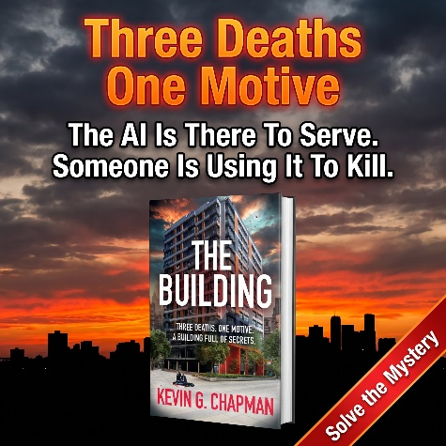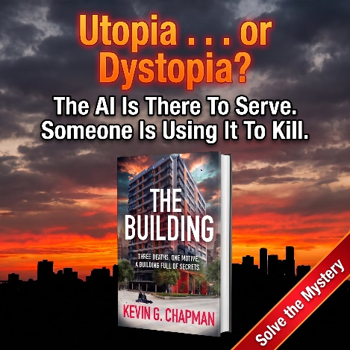

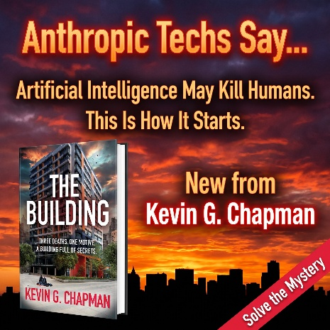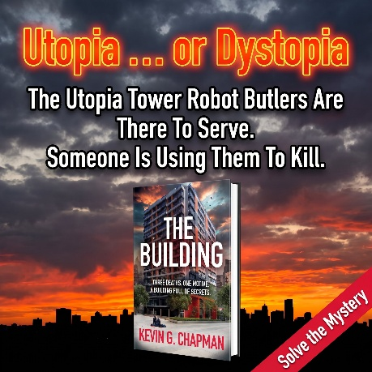

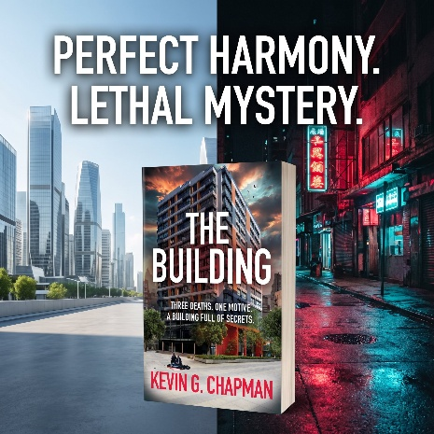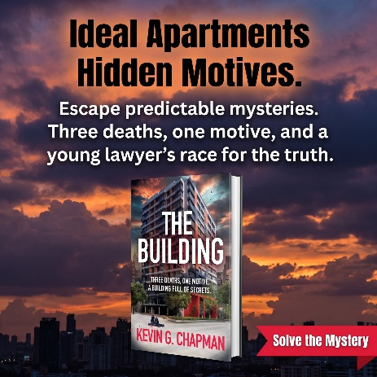
C. TikTok Video. Upload video from this link: https://drive.google.com/file/d/125YMotpkTbAsE1azAfo58KXiOlYivMxA/view?usp=drive_link
Accompanying text: Get this! https://kevingchapman.com/direct-sales-best-value/

